**Low level Design**

Insurance premium prediction

Written by : Akhil Pratap singh

Document version : 1.0

Last revised date :16/04/2023

**Document control**

**Change record:**

|  |  |  |  |
| --- | --- | --- | --- |
| **version** | **Date** | **Author** | **comments** |
| 0.1 | 16/04/2023 | Akhil Pratap singh | Intro and architecture defined |
| 0.2 | 16/04/2023 | Akhil Pratap singh | Unit test case appended |
|  |  |  |  |
|  |  |  |  |
|  |  |  |  |
|  |  |  |  |

**Reviews:**

|  |  |  |  |
| --- | --- | --- | --- |
| **Version** | **Date** | **Review** | **Comments** |
| 0.1 | 16/04/2023 | **Akhil Pratap singh** | **Document content version control and unit test cases to be added** |
|  |  |  |  |

**Aproval status:**

|  |  |  |  |  |
| --- | --- | --- | --- | --- |
| **version** | **Review Date** | **Reviewd By** | **Aproved By** | **Comments** |
|  |  |  |  |  |

Contents

1. Introduction………………………………………………………………………………………….1
   1. What is low level design documents……………………………………………1
   2. Scope………………………………………………………………………………………….1
2. Architecture………………………………………………………………………………………..2
3. Architecture description……………………………………………………………………..3
   1. Data discription…………………………………………………………………………3
   2. Data downloading……………………………………………………………………..3
   3. Data transformation………………………………………………………………….3
   4. Data preprocessing………………………………………………………………….3
   5. Model building…………………………………………………………………………3
   6. Data from user…………………………………………………………………………4
   7. Model call……………………………………………………………………………….4
   8. Deployment…………………………………………………………………………….4

4.0 Unit test cases…………………………………………………………………………………….4

Introduction

1. What is the low level documents?

The goal of low level design documents to give internal logical and actual program code for Insurance premium prediction. Lld describe the modules so that programmer can code directaly from the documents .

1. Scope

Low level design is a component design process that fallows a step by step refinement process .the process can be use for designing data structure required software architecture and source code , ultimately and performance algorithm . Overall, the data organization may be defined during requirements analysis and then refined during data design work .

# **Architecture**

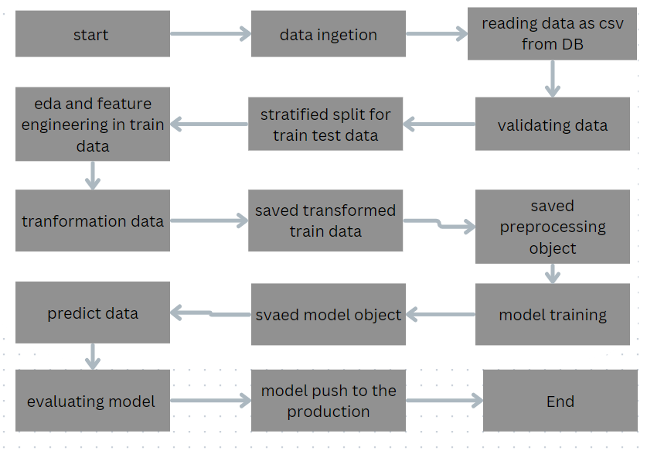

# **3.0 Architecture description**

3.1 Data Description

Insurance premium data is publically available dataset

Contain seven features and 1338 obervation .

3.2 Data Downloading

Downloading data from Cassandra DataBase into in csv

formate to perform other stage .

3.2 Data transformation

In data transformation we change categorical data into numerical feature by using one hot encoding and scalling data by using standard scalling by sklearn and merge all the dataset with eatch other

3.3 Data Preprocessing stage

In data preprocessing we are first check null values if there is any null value first we will impute null value and then perform we will check if there is any outliers we will perform the operations for other stage .

3.4 Model building

In model building first we will build basic model and then we are using grid search cv to tune the best model.

3.5 Data from user

In this stage we are taking data by html page and convert into dataframe

Then check datatype of all data then then provide data to our model

3.6 Model Call

In this stage we load the model which is saved in production to predict our data

3.7 Model deployment

In stage of deployment we use cicd pipeline to deploy whole process

Into aws account

# **4.0 Unit test cases**

|  |  |  |
| --- | --- | --- |
| **Test case discription** | **Pre – Requisite** | **Expected Result** |
| Verify the url is accessible by user or not | Application url should be defined | Application url is accessible |
|  |  |  |
|  |  |  |
|  |  |  |
|  |  |  |
|  |  |  |